Newsletter
Volume 4, Issue 1
Spring 2012
Dear Fellow SDS Members,
We are approaching another meeting. More fun, more thinking, and more challenges. I want to focus my notes today on our efforts to increase diversity within SDS.
First, I am thrilled that we have inaugurated the Chris Bell Memorial Scholarship, a scholarship for people of color to present at SDS. It honors the memory and work of our former SDS president. This award is possible due to the ground breaking donation of an active SDS member, and represents an ongoing challenge to us: the existing donation will last only two to four years if we cannot match and replenish the original donation. We ask you to donate. You can do this on the web, through the SDS registration system (with or without registering), or directly to the office. Every few dollars make a difference.
Second, as a way of reiterating SDS’s commitment to all kinds of work in disability studies, we will confer our first President’s Award for artists and activists who embody and promote the goals

Inside this Issue:

letter from the president 1
Denver 2012!
sds 2012 overview 2
accessible Denver 4
mile high trivia 5
welcome 6
sds Senior Scholar 7
sds Zola award for
emerging scholarship 8
profiles |DSQ editorial
transition
Bruce Henderson 8
Noam Ostrander 9
Brenda Brueggemann 9
Scot Danforth 10
membership report 11
member news 12
your generosity matters 17
sds board 17
sds committee roster 18

of the Society. As we confer this posthumously to Colorado-based Laura Hershey (http://www.laurahershey.com/), we will have an opportunity to really experience her unique genius and to celebrate with her Denver family and community. We can once again confirm that disability studies exists and thrives far beyond academia: in many ways this diaspora leads our freshest and most powerful work.
Finally, the SDS office is already working on 2013 in Orlando. For the first time, we have negotiated broadband internet access in the meeting rooms; now we must learn how to really leverage its capacities. We want to both increase access to SDS to those who can’t come and maintain the friendship and community that happens on-site. We want to make SDS financially accessible to a broader audience via remote access without increasing costs to those who attend in person. We are only beginning to understand the disability and communication access ramifications of various kinds of use of broadband for simultaneous remote and on-site conference access. It won’t be easy, but this is an opportunity for increased diversity that we must embrace.
This is the right time to volunteer to help us in this expansion. Tell me of your interests and skills and I will happily help you find the right committee or task force. Watch for news on the sds listserv about the upcoming board elections, and vote by May 2nd!
All my energy I will share,
Devva

sds 2012 in Denver!
from Program Committee Chairs Allison Carey and Michael Rembis

The 25th annual meeting of the Society for Disability Studies promises to be one of its most vibrant. We have received numerous excellent proposals that explore this year’s theme, “Collaborations, Cultures, and Communities,” from a diverse range of disciplines, perspectives, and geographic locations. In addition to the many areas of interest most commonly represented at SDS conferences, this year’s
conference also will have presentations in the emergent fields of Autism and Mad Studies, Fat Studies, Technology Studies, and Environmental Justice to name a few. One need look only as far as the opening plenary (7:00 PM, Wednesday, June 20, 2012) to gain a sense of the tremendous amount of diversity represented at this year’s conference. The plenary session, entitled “Dis-claimed Identities: Cross-cultural Examples of Collaboration and Community,” features three distinctly different yet uniquely related presentations. The presenters describe themselves as coming from “vastly different disciplines and backgrounds,” but they are each “deeply committed to examining disability… in a contextual and dynamic way.” They consider fundamentally important the “many factors that shape identities and societies,” including cultural practices, belief systems, and expressions. In her presentation, entitled “Removal and Belonging: Examining the Hiawatha Asylum for Insane Indians,” Susan Burch hopes to “shed light on [the] marginalized histories” of the nearly 400 men, women, and children from 17 states and nearly 50 tribes who were incarcerated at Hiawatha between its opening in 1902 and its final closing in 1934. Burch uses the life stories of institutionalized individuals, which she contends are stories of multiple “removals,” to explore the “lived realities of marginalized communities and their relationship to broader mainstream society.” Burch’s co-panelist, Jessica Lee, will explore the lived experiences of deaf Tanzanians, who, she argues, “have drastically different living situations than deaf people in the West, [and] move fluidly between groups that label themselves ‘disabled’ [and] groups who solely identify as ‘deaf’.” Finally, Eliza Greenwood will share the story of “Austin Unbound,” which she describes as “a documentary film at the intersection of the deaf community and the transgender experience.” The central focus of the film is a man named Austin who, in the midst of gender transition, is “preparing for a double mastectomy.” The plenary will feature a comment by prominent disability studies scholar and long-time SDSer Alison Kafer. In addition to the many panels featuring disability studies scholars from all over the world, the program will feature an interesting array of poster presentations, discussions, workshops, and a new book/work reception. The conference begins Wednesday evening with the opening plenary and a welcome reception. The 90-minute concurrent sessions begin Thursday morning, June 21, and run through Saturday evening, June 23. The new poster session and the book/work reception will take place Thursday evening. If you have not made arrangements to have your new book/work displayed prominently at this year’s SDS, contact either one of the program co-chairs, Mike Rembis or Allison Carey, right away!
As always, the evening performances promise to be enlightening as well as immensely entertaining. Mandy Harvey a local (Denver) singer/songwriter will be performing Wednesday evening. And we have PHAMALY confirmed for Thursday evening at 8:00 pm. PHAMALY, which stands for Physically Handicapped Actors & Musical Artists League (PHAMALY), is a theatre group and touring company that performs throughout the greater Denver area. According to its website, “PHAMALY was formed in 1989 when a group of former students of the Boettcher School in Denver, Colorado, grew frustrated with the lack of theatrical opportunities for people living with disabilities and decided to create a theatre company that would provide individuals with disabilities the opportunity to perform.” The highlight of the conference, of course, will be the annual SDS dance, which will take place Saturday night, June 23, 2012.
New this year, the program committee has decided to implement a series of strands that will enable conference attendees to attend multiple sessions on a common theme. We have especially rich offerings in the areas of religion and religious communities, power and privilege, and professional development. Each one of the strands will be marked prominently on this year’s program. Try not to miss them!
We look forward to seeing everyone in Denver!
For more information, please contact Mike at marembis@buffalo.edu and/or Allison at accare@ship.edu.

accessible Denver
By Bill Lundgren, Site Committee
If you are thinking about attending the SDS Conference in Denver and have some concerns about special equipment, equipment repairs, or where to find
resources particular to your needs, check out the Accessible Denver web site: www.denvergov.org/accessibledenver.
Created by members of the Denver Commission for People with Disabilities, the web site offers a variety of listings to help visitors with special requirements feel as comfortable in Denver as they would if they were home. If what you are looking for is not on the web site, let us know so we can see whether we can find what you need. It will help us keep our listings as complete as possible. Also check out the travel tips and information, as well as the links for additional helpful suggestions for your travel.
Additional web sites for recreation and special events in the Denver area:
www.Visitdenver.com
www.greatwheelchairaccessiblehikes.com (click Colorado)

mile-high trivia
- Denver really is exactly one mile high. A step on the State Capitol Building that is exactly 5,280 feet above sea level.
- In Denver’s rarified air, golf balls go ten percent farther. So do cocktails. Alcoholic drinks pack more of a wallop than at sea level. The sun feels warmer, because you’re closer to it, but your coffee is cooler, because water boils at 202 degrees.
- Denver is near the mountains, not in them. There are 200 named peaks visible from Denver, including 32 that soar to 13,000 feet and above. The mountain panorama visible from Denver is 140 miles long.

- Denver has 300 days of sunshine a year. Located east of a major mountain range, Denver has a mild, dry and sunny climate with more annual hours of sun than San Diego or Miami Beach.

- The nation’s third largest Gay Pride Festival will take place in Denver the weekend just before the SDS Convention opens.

- Denver brews more beer than any other city. Coors Brewery is the world’s largest. Denver’s Great American Beer Festival is the largest in the nation with 2,400 different beers. The Wynkoop Brewing Company is the largest brewpub in America. On an average day, Denver brews more than 100 different beers.

- Denver is a cultural city with the second highest educated population in America.

- The Denver Center for the Performing Arts has theater space that is fully accessible backstage as well as being fully accessible for audiences. It was the first performing arts center to provide listening devices for theater patrons.
- Denver has the 10th largest downtown in America and one of the most exciting and walkable. Within a mile radius, downtown Denver has three major sports stadiums, the nation’s second largest performing arts center, three colleges, an assortment of art and history museums, a river offering white water rafting, more than 8,400 hotel rooms, a $140 million amusement park, a $100 million aquarium and 300 restaurants.
- Downtown Denver is just a 20-minute ride by light rail from your hotel.

WELCOME to the mile-high city!
We are delighted that the Society for Disability Studies 25th Conference will be in our accessible city. We promise to do everything we can to make your visit as enjoyable and productive as possible. For starters, the lobby of the Denver Marriott Tech Center will have easels displaying visual arts done by talented artists from the disability community. We are presenting some of the best performers who happen to have disabilities: A wonderful performer, Mandy Harvey, will sing Wednesday night prior to and after the Opening Plenary to set a lyrical tone for the conference. Thursday night will feature Phamaly (Physically Handicapped Actors and Musical Artists league) to entertain you with a taste of Broadway performances that have wowed theater goers wherever they have appeared. These performances will be sponsored by the City of Denver agency for Human Rights and Community Partnership (HRCP).
Denver’s greatest asset, of course, is its people! We will have volunteers throughout the conference site ready to help you find out what a livable, accessible city Denver truly is for people with disabilities and their allies. Disability Pride is truly the operant term in Denver.
We hope you will attend the 25th Annual SDS Conference June 20-23. Come to Denver early or stay afterwards to enjoy sports activities, cultural events and historical sites that make Denver unique.
We look forward to seeing you there!
William Lundgren & Ed Neuberg
Co-Chairs for Site Committee
25th Annual Conference
To enjoy early-bird registration rates, register on or before May 1!
It is possible to register and submit payment by check within two weeks.
Visit disstudies.org to register !
***
mile-high traveler’s tips:
To combat the effects of high altitude,
wear lots of sunscreen, drink lots of water,
and count on some down time the first day to help your body adjust.

sds 2012 Senior Scholar Award

Carol J. Gill, Ph.D. – winner of the 2012 SDS Senior Scholar Award

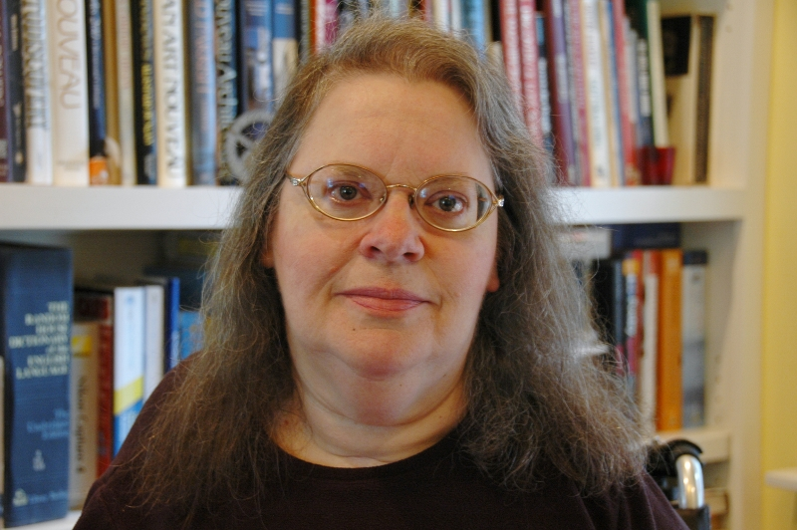 | We are pleased to announce the winner of the 2012 senior scholar award, selected by a committee of peers and nominated by SDS members.  Here are some excerpts from Prof. Gill’s nomination and letters of support that capture her essence as Disability Studies senior scholar: “Dr. Gill is an Associate Professor of Disability Studies at the
University of Illinois at Chicago. She earned her Ph.D. in psychology from the University of Illinois, Urbana Champaign. She got involved in disability activism, independent living and disability studies in Los Angeles, where she met Irving Zola, Diane Coleman and many other emerging leaders and activists in the disability movement. She worked as a rehabilitation psychologist and she directed a pioneering disability studies program at the University of Southern California. After she returned to Illinois in 1996, she joined the faculty of the University of Illinois at Chicago and founded the Chicago Institute of Disability Research, which she continues to direct today.”
“Dr. Gill has made diverse, significant, and lasting contributions to the establishment of disability studies as a scholarly field. Dr. Gill has made significant research contributions in areas of disability identity and community, disability culture; sexuality; parenting; women with disabilities’ access to healthcare; training of healthcare professionals to provide more appropriate care to persons with disabilities; and perhaps most notably, in her scholarly writings that challenge the devaluation of disabled people in bioethical debates.”

“Unlike many scholars who are known within their own circles, Carol’s influence and reputation extend broadly to field such as rehabilitation, literature, cultural and women’s studies, ethics, and history. Such broad reach takes disability studies beyond its own boundaries to audiences who can and must think of disability in progressive and creative ways necessary to make profound and sustained change in rights and participation.”

“I believe Carol is the perfect candidate for this award, not only for her significant scholarship, teaching and mentoring within Disability Studies, but also for her groundbreaking work as a disability rights activist, indeed setting the stage in the U.S. for the creation of the Society of Disability Studies and the field of Disability Studies as coming from within disability communities and led by disabled people.”

“Perhaps one of the key signs of a senior scholar is to see the legacy impact upon students who then become central scholars in the field themselves; this is evident in Dr. Gill’s legacy.”

Irving K. Zola Award for
emerging scholarship in disability studies

Jina Kim is a Ph.D. candidate in the Women's Studies and English joint program at the University of Michigan, Ann Arbor. A Georgia native, she received her B.A. from Agnes Scott College in 2007. Her research interests include contemporary multi-ethnic American literature, disability studies, women of color feminist critique, and performance studies. Kim will present her award-winning essay, “The People of Apokalis: Spatial Disability and the Bhopal Disaster,” at sds in Denver. | 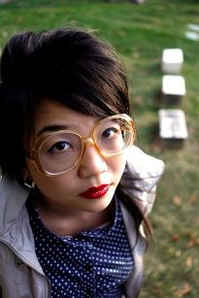
Renewed congratulations to Professor Carol Gill and Jina Kim, and warm thanks to those of you who participated in the SDS award processes. As ever, we had an embarrassment of riches this year, a testament to the strength of our community and the fantastic work being done in disability studies!

announcing the DSQ editorial transition!

incoming |Bruce Henderson…
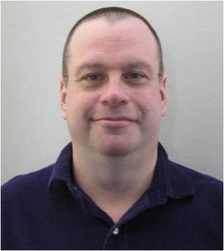 | Bruce Henderson is Professor of Speech Commu-nication and Coordinator of the Program in Culture and Communication and the Minor in Health Communication at Ithaca College. He has his B.S., M.A., and Ph.D. in Performance Studies (formerly Interpretation) from Northwestern University and a Ph.D. in Disability Studies from the University of Illinois at Chicago. His primary teaching areas include performance of literature, folklore and storytelling, health communication, and interdisciplinary courses in
disability studies, cultural studies, and aging studies. He is co-author of the textbook Performance: Texts and Contexts and Learning to Perform: An Introduction, and co-editor of Understanding Disability Studies and Performance Studies. He has also published widely in such fields as 20th century literature, children’s literature, and LGBT/Queer studies. In addition, he is a frequent performer and director. The National Communication Association (NCA) honored Henderson with its Lilla A. Heston Award for Outstanding Scholarship in Interpretation and Performance Studies in 2011.
…and Noam Ostrander
Noam Ostrander, PhD, LCSW serves on the faculty of DePaul University’s Master of Social Work (MSW) Program. He received his A.M. from the School of Social Service Administration at the University of Chicago and his Ph.D. in Disability Studies at the University of Illinois at Chicago. Prior to joining the faculty, Dr. Ostrander worked with former gang members who sustained violently- | 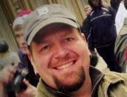
acquired disabilities. Additionally, he served as a clinical therapist for members of LGBT communities. Dr. Ostrander has published articles on disability identity formation, sexuality, and social work education in journals such as Child and Adolescent Social Work Journal, Disability and Society, and Disability and Sexuality. Recently, he has co-edited a book with Bruce Henderson entitled,
Understanding Disability Studies and Performance Studies (Routledge). Dr. Ostrander has presented his research at numerous major conferences in the United States and has been an invited speaker at colleges and universities across the globe on disability and violence.
thanks so much | Brenda Brueggemann…
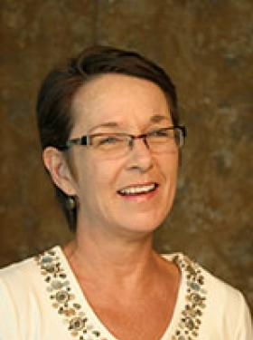 | Brueggemann is the author of Lend Me Your Ear: Rhetorical Constructions of Deafness (1999) and Deaf Subjects: Between Identities and Places (2008), and co-editor and contributor Disability Studies: Enabling the Humanities; Women and Deafness: Double Visions; Disability and/in Prose; Disability and the Teaching of Writing: A Critical Sourcebook. She is series editor for "Deaf Lives: Autobiography and Biography," at Gallaudet University Press. Brueggemann has been recognized with numerous professional awards for exemplary achievement in teaching and research, most recently with the 2011
Arts & Sciences Student Council Outstanding Teacher Award and the 2011 Rodica Botoman Distinguished Teacher in the Humanities Award.

…and Scot Danforth
Scot Danforth serves as the Director of the School of Teacher Education at San Diego State University. Previously, he served as Professor in the College of Education and Human Ecology and Coordinator of the Ph.D. program in the School of Teaching and Learning at The Ohio State University and as Chair of the Division of Teaching and Learning at the University of Missouri, St. Louis. He is the author of 50 articles or book chapters and has authored or edited seven books, including his most recent book, The Incomplete Child: An Intellectual History of Learning Disabilities (2009). Danforth also co-authored Cases in Behavior Management (2006), Engaging Troubling Students: A Constructivist Approach (2004), Crucial Readings in | 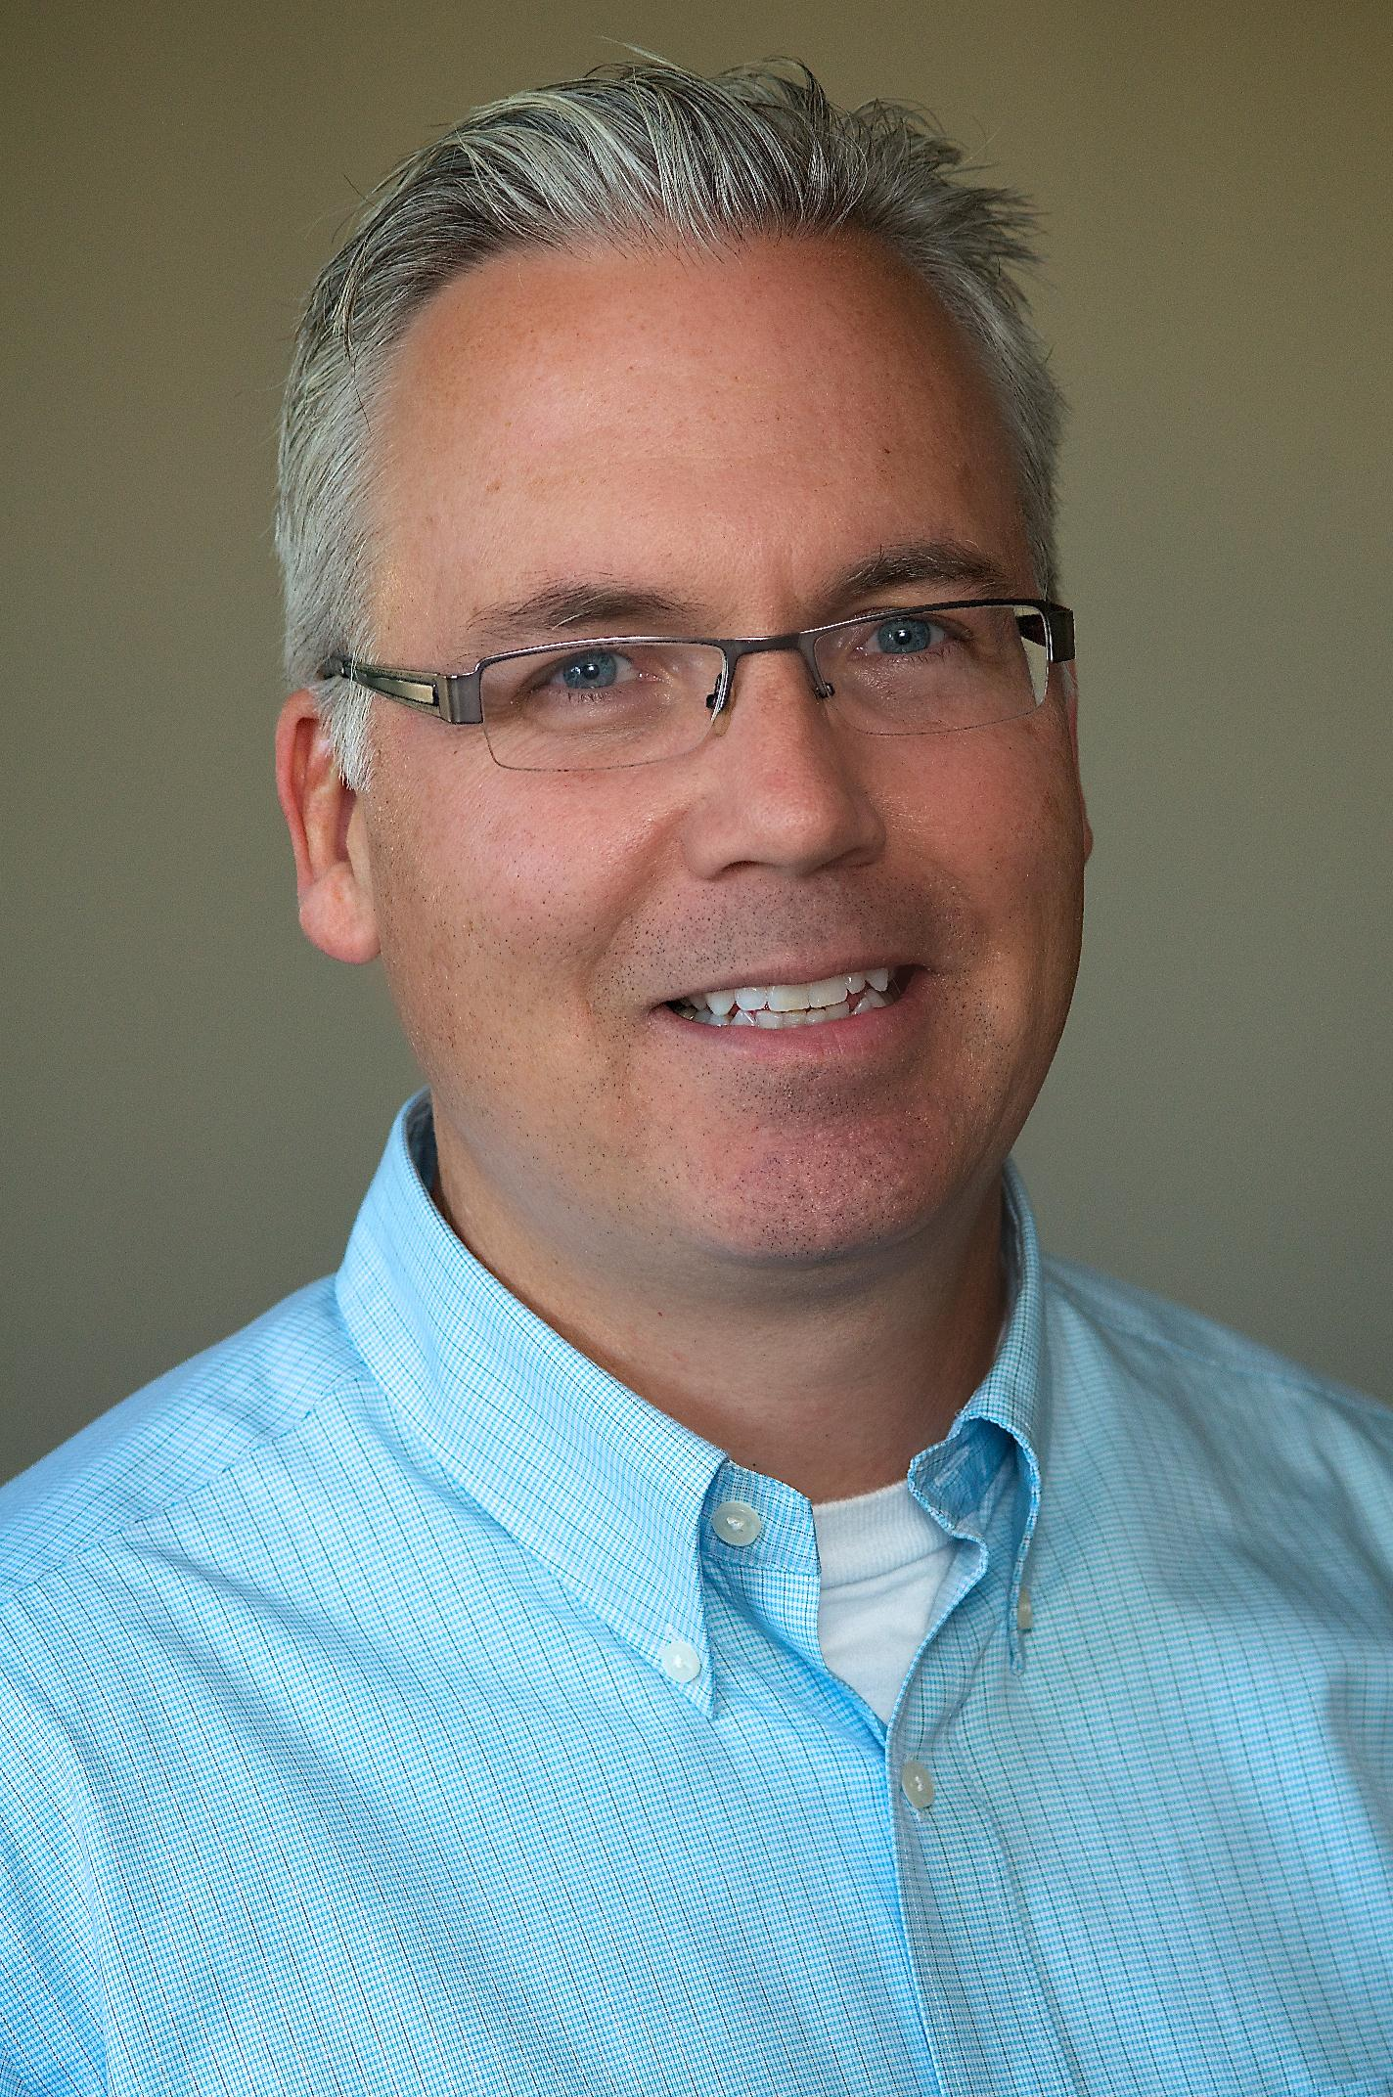
Special Education (2003), and co-edited Vital Questions Facing Disability Studies in Education (2007) Disability and the Politics of Special Education (2008).

SDS would like to extend its heartiest thanks to Brenda and Scot for
their six years of service to DSQ: Disability Studies Quarterly as its co-editors.
Their work has been essential and visionary!

Thanks also to Sue Baglieri, who led the search process for a new editorial team, and to the many people in the sds community who served that process. Board member Sami Schalk will be meeting with Brenda, Noam, Bruce, and the OSU library team next month to ensure a smooth transition.

membership report
Joan Ostrove (Chair)
Funmi Akinpelu and Sami Schalk (Assistant Chairs)

Thanks very much to those of you who have renewed your membership in SDS for 2012. As of right now, we have 283 “paid up” members. That’s a pretty decent number, but there are still about 220 people who were members in 2011 who have not yet renewed. If you are one of those people, please renew today using the “renew” link on the SDS website: http://disstudies.org/memberships/member_renew.php.
I know many of you are accustomed to renewing immediately before you register for the SDS conference. In the past that’s been a fine time to renew, and of course that time is right now, as conference registration is open and ready for you as well. We have, however, transitioned to a calendar year membership, so when 2013 is upon us in December, please plan to renew then, or in early January. We will have a much better sense of the consistency and size of our membership if we can more effectively separate it from the conference registration “rush” in April and May. Thank you!
Also, please consider inviting someone who has never been a member of SDS to join the organization. People who are new to SDS (as well as those who haven’t been dues-paying members in a while) need to fill out a membership application, available at http://disstudies.org/sds-membership/join-sds/.
Thanks as always for your support of SDS. The effective functioning of the organization depends heavily on your membership dues, which are greatly appreciated.
If you have additional ideas or want to join the Membership Committee, please contact Joan (ostrove@macalester.edu), Sami (sami.schalk@gmail.com) or Funmi (funmiakinpelu2000@yahoo.com )

Spring elections are here!
Nomination statements from potential board members, a ballot and a time line for board elections will soon be announced via the sds listserv.
Don’t forget to vote!

Direct questions about board elections to Liat Ben-Moshe, lbenmosh@uic.edu
or Pratik Patel, pratikp1@gmail.com

sds member news

From Allison Carey:
Recognizing that public history can play a vital role in connecting communities, the Institute on Disabilities at Temple University is working to capture the oral histories of leaders in Pennsylvania’s Intellectual Disability Movement through its Visionary Voices | Leaders Lessons Legacy Project. By December of 2012, fifty video oral interviews chronicling Pennsylvania’s role in the Movement will be available to the public through the project’s website.
The Visionary Voices website will also feature a finding aid for the Haggerty Papers, a personal papers collection donated to the Institute by Dennis Haggerty. As an attorney, advocate, and parent of a son with an Intellectual Disability, Mr. Haggerty was active in the parent movement at both the local and national level and was one of the forces behind the Right to Education case that opened schools in Pennsylvania to children with disabilities. The Haggerty Papers chart the history of Pennsylvania’s Intellectual Disability Movement from 1968 – 1980s, through personal and professional correspondence, publications, news clippings and images.
Together, the oral histories and Haggerty Papers offer fascinating, first-person account of the events that changed the lives of Pennsylvanians with Intellectual Disabilities. It is the Institute’s hope that the Visionary Voices website will serve as a vital resource for students, teachers, scholars, people with disabilities, families, policymakers and members of the media.
Visit the website at: www.disabilities.temple.edu/voices
For more information, contact Lisa Sonneborn, Project Coordinator for Visionary Voices at 215.204.9542 (voice), 215.204.1356(voice/TTY) or lisa.sonneborn@temple.edu (email).
Debbie Engelen-Eigles received a Fulbright Research Award to Seoul, Korea to study the experiences of Korean women with disabilities in accessing health care. She has been in Seoul since last July and reports that it has been an amazing experience.
Doris Fleischer reports three recent publications:
Doris Zames Fleischer and Frieda Zames. The Disability Rights Movement: From Charity to Confrontation (updated edition).Philadelphia: Temple University Press, 2011. Print (This text has been published in both hardback and paperback editions.)
Doris Zames Fleischer. "The Rights of the Disabled." Handbook of Human Rights. Ed. Thomas Cushman. New York: Routledge,2012. 373-384. Print.
Doris Zames Fleischer aand Frieda Zames. "Disability and the Media in the 21st Century." Studies in Communication: Volume 6, Human Rights and Media. Ed. Diana Papademas. United Kingdom: Emerald Group Publishing Limited, 2011. 181-218. Print.
Gili Hammer published “Blind Women's Appearance Management: Negotiating Normalcy between Discipline and Pleasure” in Gender & Society. First published on March 26, 2012 as doi:10.1177/0891243212438263
Jill Le Clair announces an upcoming photography exhibit and a special issue of Sport and Society:
Photography Exhibit: Sport Cultures: Movement, Identities and Inclusion
Theme: Inclusion and accessibility in sport and movement (games, play, dance, walking etc.) across age, gender, ethnicity and dis/ability (http://cargo.collective.com/photosforall
When: May 1 – May 25, 2012
Where: Three City of Toronto venues: the Rotunda of New City Hall, North York Civic Centre & the Rotunda Metro Hall
Toronto, Canada at the ScotiaBank CONTACT Photography Festival http://scotiabankcontactphoto.com/
Who: Professional and amateur photographers present the work of researchers, activists, and sport, disability, art and community organizations
Curators: Dr. Nancy Halifax, York University, Dr. Jill M Le Clair, Humber College ITAL, & Nafisa Fera, Royal Anthropological Institute, London, England
Special Issue of Sport in Society Journal: Disability in the Global Sport Arena: Sporting Chance, ed. Jill M. Le Clair
vol 14, issue 9 November, 2011 http://www.tandfonline.com/loi/fcss20?open=14#vol_14
This is a collection of multi-discipline, cross-disability articles about physical activities that are local, national and global by researchers from Australia, Canada, China, Fiji, France, Ghana, Iran, Kenya, Malaysia, South Africa, United Kingdom and the United States. It includes papers on the Deaflympics, the Paralympic Games and Special Olympics.

Carla Lewis-Irizarry reports that she will be graduating this coming June with her second masters in Disability Studies at the School of Professional Studies in New York. This past January, she was appointed by New York Governor Andrew Cuomo and by the New York State Independent Living Council (NYSILC) to serve a three-term as a State Council Member.
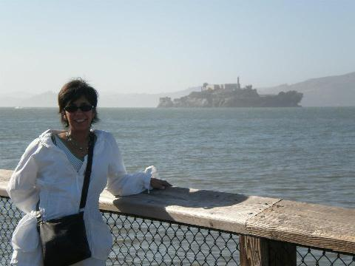  Michelle at SDS ’11 in San Jose!  Feeling nostalgic? Come to Denver! | Michelle Nario-Redmond was awarded tenure and promoted to the rank of associate professor of Psychology at Hiram College. She also reports a new publication in press: Nario-Redmond, M.R., Noel, J. G, & Fern, E. “Redefining Disability, Reimagining the Self: Disability Identification Predicts Self Esteem and Strategic Responses to Stigma” in Self and Identity. Let Michelle know if you would like an advance copy!
Susan Roush published an article that introduced the Social Model of Disability to the Physical Therapy profession: Roush SE, Sharby N. “Disability reconsidered: the paradox of physical therapy.” Phys Ther. 2011;91:1715-1727.

Daniel Salomon published Have Mercy On Me, An Ecological Sinner: How The God Of The Bible Helped Me Rise Above Compassion Fatigue and Not Give-Up On The Ecological Struggle (Amazon.com, 2012).
Salomon is back with an all-new book on Christian ecotheology, with the goal of “breaking the silence” on “political polarization” and “compassion fatigue.” Salomon candidly takes on positively, constructively, and sympathetically, the highly controversial, highly taboo, yet highly urgent topics of “political polarization” and “compassion fatigue” in politics and religion. All this is within an ecological-planetary context, including animals, disability, and neurodiversity.

Angela M. Smith, assistant professor in English and Gender Studies at the University of Utah, announces the publication of her book Hideous Progeny: Disability, Eugenics, and Classic Horror Cinema, with Columbia University Press.
Twisted bodies, deformed faces, aberrant behavior, and abnormal desires characterized the hideous creatures of classic Hollywood horror, which thrilled audiences with their sheer grotesqueness. Most critics have interpreted these traits as symptoms of sexual repression or as metaphors for other kinds of marginalized identities, yet Angela M. Smith conducts a richer investigation into the period's social and cultural preoccupations. She finds instead a fascination with eugenics and physical and cognitive debility in the narrative and spectacle of classic 1930s horror, heightened by the viewer's desire for visions of vulnerability and transformation. Smith’s work profoundly advances cinema and disability studies, in addition to general histories concerning the construction of social and political attitudes toward the Other. For more information, see
http://cup.columbia.edu/book/978-0-231-15716-2/hideous-progeny
Anyone in North America who uses the promo code “HIDSM” to buy the book from this site will receive a 30% discount off the price of the book.
Tanya Titchkosky announces her new book, The Question of Access: Disability, Space, Meaning, University of Toronto Press, 2011.
Values such as ‘access’ and ‘inclusion’ are unquestioned in the contemporary educational landscape. But many methods of addressing these issues – installing signs, ramps, and accessible washrooms – frame disability only as a problem to be ‘fixed.’ The Question of Access investigates the social meanings of access in contemporary university life from the perspective of Cultural Disability Studies. Through narratives of struggle and analyses of policy and everyday practices, Tanya Titchkosky shows how interpretations of access reproduce conceptions of who belongs, where and when. Titchkosky examines how the bureaucratization of access issues has affected understandings of our lives together in social space. Representing ‘access’ as a beginning point for how disability can be rethought, rather than as a mere synonym for justice, The Question of Access allows readers to critically question their own implicit conceptions of disability, non-disability, and access.

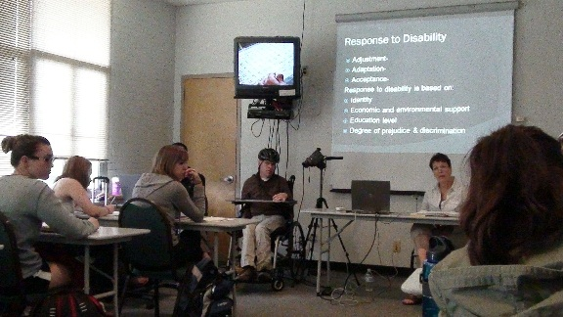 | Member Matthew Wangeman reports that Northern Arizona University (NAU) has a new Minor in Disability Studies. The Minor officially started Fall 2010 and currently has over twenty students enrolled! The Institute for Human Develop-ment (IHD) developed and administers the Disability
Studies Minor at NAU. IHD, which is a University Center of Excellence in Developmental Disabilities (UCEDD), found that in 2006 Arizona’s citizens with disabilities and their family members ranked attitudinal barriers as being a primary issue holding people with disabilities back from reaching their full potential. The Minor was established at NAU as one of the ways to address attitudes about disabilities and to help students recognize that disability is a natural part of life. By participating in the Minor, it is our hope that students critically examine their own personal attitudes towards disability while reflecting on the construct of “normality” and the ways in which this construct has shaped society’s perception of disability.
During the last three years, the Minor has received recognition from various sources. The College of Social and Behavior Sciences at NAU in 2011 presented their “Innovation in Teaching” Award to two instructors who co-teach the Introduction to Disability Studies Course. The local NPR Radio Station (KNAU) did a brief piece about one of the instructors who has a significant disability, and last October, the Article “Teaching using Mediated Communication at a University” was published in the online Journal of SDS Quarterly.
We, at IHD, are very pleased about our progress and we hope the Disability Studies Minor will have a positive impact on students and people with disabilities in Arizona. IHD’s Website is: http://nau.edu/sbs/ihd/ .

Disability and Ability: How Young People with Impairments Make the Transition to Adulthood
Researchers at the University of Sydney (Nikki Wedgwood, Gwynnyth Llewellyn, Russell Shuttleworth and Louisa Smith) have received three years of government funding to investigate how one hundred young Australians with a variety of impairments experience the transition to adulthood. We know having an impairment can play out very differently during different life phases and that, compared to their able-bodied peers, young people with a long-term impairment have an increased risk of negative social, physical and mental health outcomes. Yet little is known about how, in a disablist society, young people with impairments meet the critical developmental and structural milestones of the transition to adulthood. Thus, based on an initial life history interview and two follow-up interviews one year apart with participants aged 19-26, this study seeks to produce new knowledge to determine how to best support young people with impairments in their transition to adulthood.

Your Generosity Matters
Become an Organizational Member and/or Supporter of SDS
Increasing the financial capacity of SDS is essential to maintaining the health of the organization, as well as to initiate and support programs that benefit our members and further the work of disability studies. Your donation provides support for:
- Disability Studies Quarterly—the first journal dedicated to disability studies
- Travel Scholarships—to enable more members to participate in the annual conference
- The Affiliated Scholar Program—a new initiative, which provides access to resources through academic institutional affiliations for an independent scholar
- The daily operations of SDS

The Organizational Membership is a package of benefits designed just for institutions of higher learning or other organizations. For $250 per year, organizational members:
- May nominate up to two student/low-income members for free SDS memberships
- Can post freely to a job page on the SDS website and listserv
- Are listed in the conference program as supporters of SDS
- For more information go to: http://www.disstudies.org/membership/membership_type/
To learn more options for donating to SDS, please visit our website at: www.disstudies.org
SDS thanks all of those individuals and organizations that support SDS through financial, in-kind, and volunteer contributions!

sds board members
Devva Kasnitz, President Mariette Bates, Treasurer
Tammy Berberi, Vice President Funmi Akinpelu, Secretary
Liat Ben-Moshe Sami Schalk
Allison Carey Sunaura Taylor Joan Ostrove Russell Vickery
Pratik Patel Gregor Wolbring
Michael Rembis Frank Wyman
Alberto Guzman - ex officio

sds committees
We thank all of you who serve on SDS Committees. If you are interested in volunteering for an SDS committee, please contact the chair of the committee of interest or SDS Secretary, Funmi Akinpelu.
Awards Committee: Liat Ben Moshe, Sunaura Taylor
Affiliated Scholar Program, Alberto Guzman, albertog@email.arizona.edu
Fundraising, Frank Wyman, chips314@aol.com
Membership, Joan Ostrove, ostrove@macalester.edu, Sami Schalk, sami.schalk@gmail.com
Nominations/Elections, Liat Ben-Moshe, lbenmosh@uic.edu and Pratik Patel, pratikp1@gmail.com
Policy, Devva Kasnitz, devva@earthlink.net
Program Committee, Allison Carey, accare@ship.edu and Michael Rembis, mrembis@gmail.com
Local Arrangements: Alberto Guzman, alberto@email,arizona.edu, Russell Vickery, russell@rjv@co.nz
Research and Publications, Tammy Berberi, berberit@morris.umn.edu, and Gregor Wolbring, gwolbrin@ucalgary.ca

AD HOC COMMITTEES
By-law revision, Frank Wyman, chips314@aol.com
DSQ transition team: Brenda Brueggemann, Sami Schalk, sami.schalk@gmail.com, Tammy Berberi berberit@morris.umn.edu, Gregor Wolbring, gwolbrin@ucalgary.ca
Website redesign, Tammy Berberi, berberit@morris.umn.edu

