Winner of the 2017 SDS Senior Scholar Award
Professor Nirmala Erevelles (University of Alabama)

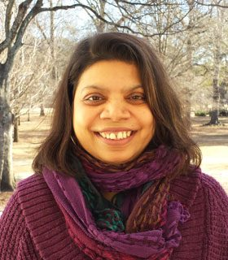
The Society of Disability Studies (SDS) recognizes Professor Nirmala Erevelles as its recipient of the 2017 SDS Senior Scholar Award for her extraordinary scholarship, service, mentoring, and leadership. Professor Erevelles explores disability as a critical and central analytic with transformative potential in addressing topics such as inclusive schooling, critical/radical pedagogies/curricula, HIV/AIDS education, facilitated communication, school violence, multicultural education, and the sex curriculum. She has has strengthened community-university partnerships through her deep commitment to intersectional analysis that considers the collusions of imperialism, capitalism, and white supremacy in the making and (or becoming) of disability. Her teaching and research interests lie in the areas of disability studies, critical race theory, transnational feminism, sociology of education, and postcolonial studies.

Professor Erevelle’s book, Disability and Difference in Global Contexts (2012), is highly regarded within the disciplines of disability studies, education, critical race, feminist, and decolonial studies. One of her nominators commented that, “[this] book challenged the field to move away from Eurocentric, unequivocally celebratory, identity-based approaches and to consider the role of nation, capitalism, and race in the shaping of people’s understandings and experiences of disability.” Another one noted that the, “beautifully poetic ways she interweaves her own and other’s personal narratives with highly complex philosophical theories and concepts make her work accessible to readers beyond academic sphere and attract a wide range of readers.” A colleague wrote that, “her research pushes the boundaries and borders of academic disciplines and expands potentials of these disciplines by demanding them to critically engage with social issues at a deeper and more complex level and in the globalizing arena.” In addition to her book, Professor Erevelles has published articles in the American Educational Research Journal, Educational Theory, Studies in Education and Philosophy, the Journal of Curriculum Studies, Teachers College Record, Disability & Society, Disability Studies Quarterly, & the Journal of Literary and Cultural Disability Studies, among others.

Complementing her stellar scholarship, SDS notes that Professor Erevelles has worked strenuously to teach and mentor hundreds of students, many of whom carry on a tradition of engaged scholarship, mentoring and activism. In their letters of support, one wrote,“Professor Erevelles makes a point of collaborating with more junior scholars. I am truly thankful of her willingness to treat us as intellectual equals despite her senior status.” Another added,“[even] though I was not a graduate student at her institution, her generosity to mentor me and guide my scholarship has never stopped at the institutional wall.”

Professor Erevelles is a faculty member in the Social and Cultural Studies in Education at the University of Alabama and received her Ph.D. and M.S. degrees from Syracuse University in Cultural Foundations of Education and Special Education; and a B.Sc. from Stella Maris College, Madras University in Mathematics.

