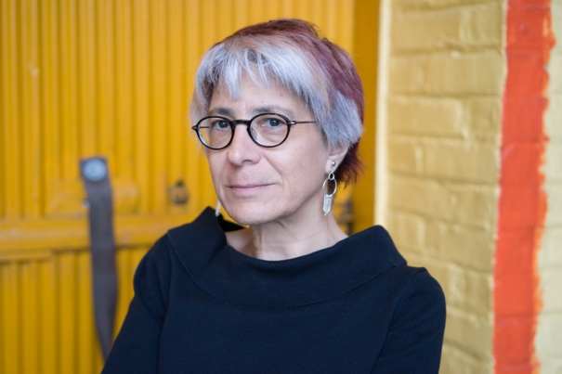
Winner of the 2017 SDS Presidential Award
Riva Lehrer (artist, writer, curator, and teacher)
The Society for Disability Studies (SDS) recognizes Riva Lehrer for its 2017 SDS Presidential Award. An artist, writer, curator, and educator, Riva Lehrer’s series of portraits of people with what she calls the “socially challenged body” have been shown at the National Portrait Gallery of the Smithsonian, the United Nations, the National Museum of Women in the Arts in Washington, DC, the Arnot Museum, the DeCordova Museum, the Frye Museum, the Chicago Cultural Center, and the State of Illinois Museum, amongst others. She is one of the most widely recognized disabled artists of her generation and her portraits of many of the significant figures in the intersectional disability rights and activism movement have been widely recognized for their stunning beauty and complexity.
Lehrer grew up in Cincinnati where she attended the Condon School for Handicapped Children. She writes that as a child, she underwent numerous surgeries because of her spinal bifida in an attempt to make her body look more “normal.” After graduating, her experiences with hospitals led her to an interest in medicine, but discrimination prevented her from being accepted at any medical schools. Drawn to the complexity of the lives that inhabited marginalized bodies like hers, she turned to painting and mixed media as a means of expression. Lehrer began the Circle Stories series in 1997 – a series of collaborative works done with her subjects, all of whom had significant physical disabilities and many of whom are recognized as core figures within disability arts, activism, and scholarship, including: Eli Clare, Susan Nussbaum, Rebecca Maskos, Tekki Lomnicki, and others.
Lehrer’s other awards include the MacDowell Colony Fellowship (2017), Three Arts Residency Fellowship at the University of Illinois (2015); the Mellon Residency Fellowship at Haverford and Bryn Mawr Colleges (2014); the Three Arts Foundation Grant (2008); and the Wynn Newhouse Award for Excellence (2006). She has also been recognized by the National Endowment for the Arts. Riva Lehrer has been a major contributor to the Society for Disability Studies for many decades. The Society awards her the Presidential Award in recognition of her support, her scholarship, and for helping people see the beauty of disabled bodies.

